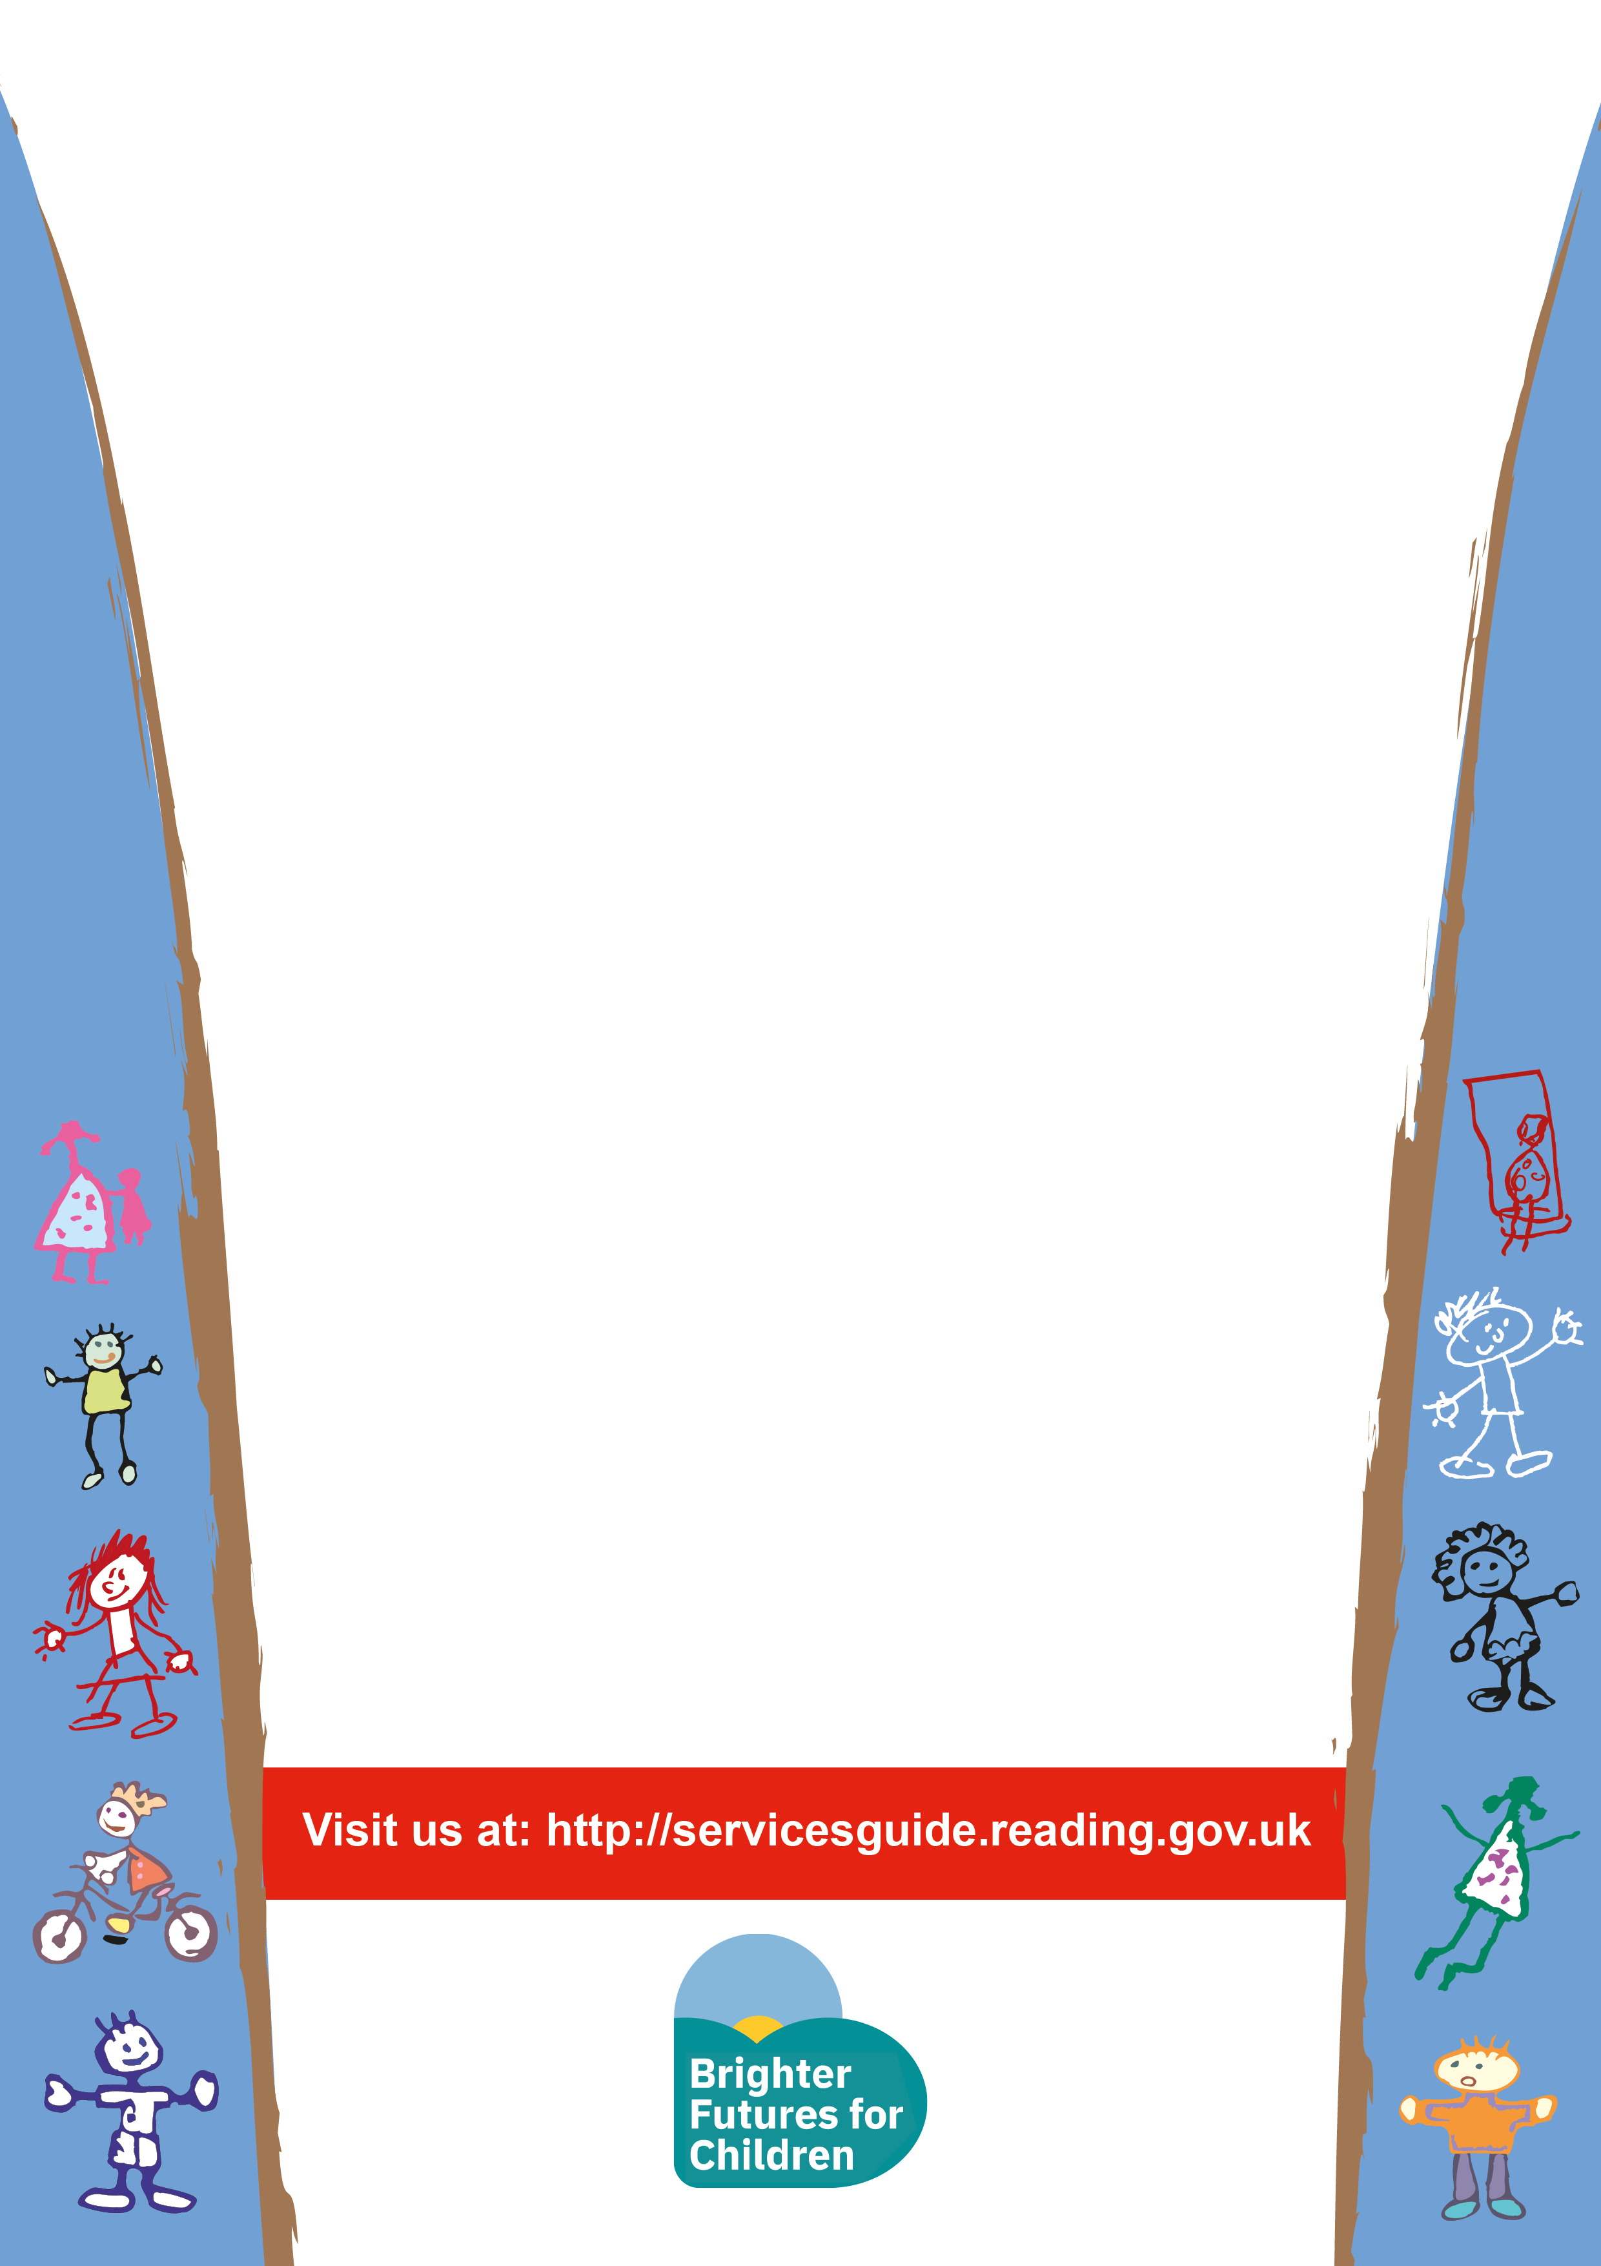
Baby Messy Play
Time: 10:00-11.30am
Venue: Sun Street Children’s Centre
Wednesday 10th July 2019
Children under 18months Only

Booking essential please drop in at Sun Street or call 01189 374602

This session is an opportunity for parents to understand how their baby learns and develops through messy play activities.



