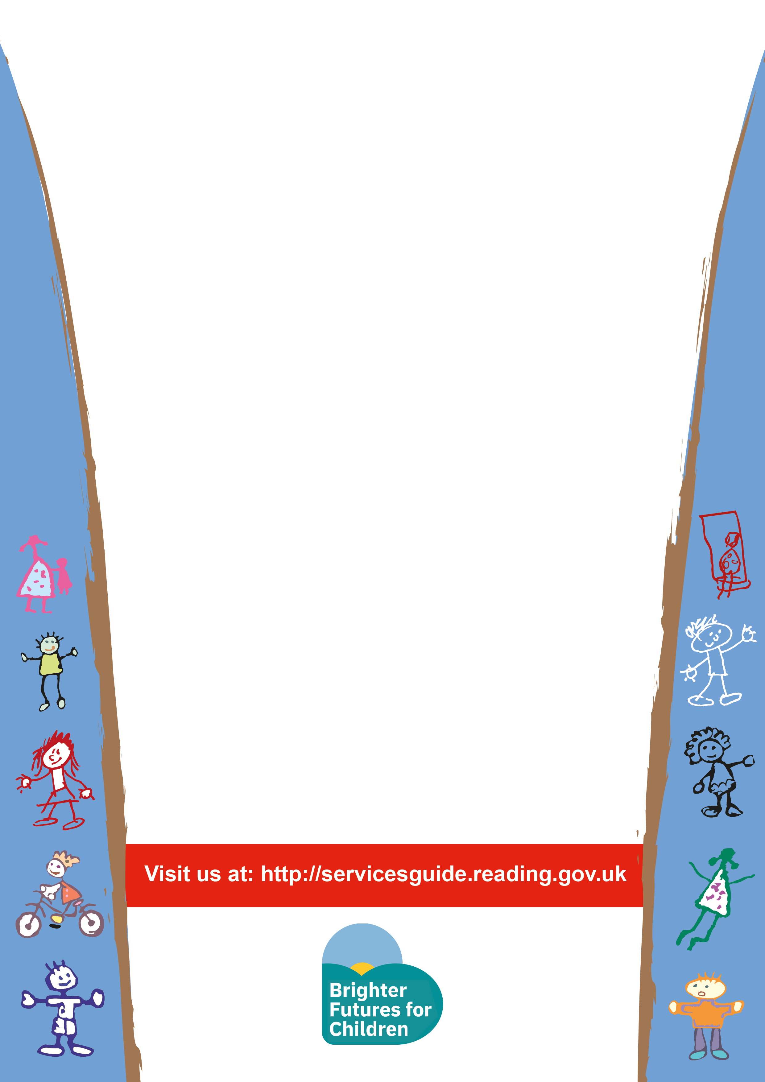
Bumps and Babes

Time: 9:30 – 11:00
Venue: Sun Street Children’s Centre
Every Friday
Children 0 to 12months

This session is:
- To provide information about babies stages of development and how best to support this
- Socialize with other parents
- Allow you child to explore a new environment and toys.



