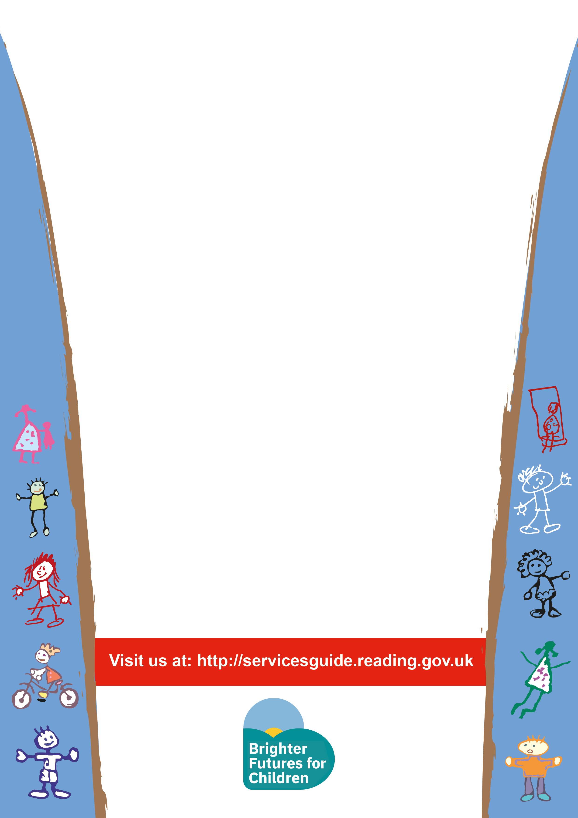
Bumps and Babes

Time: 9:30 – 11:15
Venue: Caversham Children’s Centre
Every Monday
Children 0 to 12months

This session is:
- To provide information about babies stages of development and how best to support this.
- Socialize with other parents.
- Allow you child to explore a new environment and toys.



