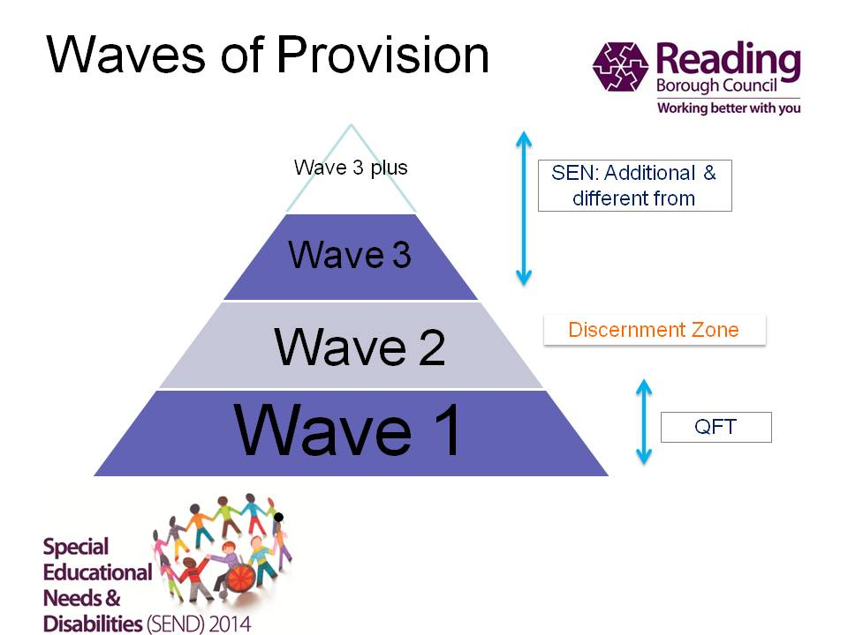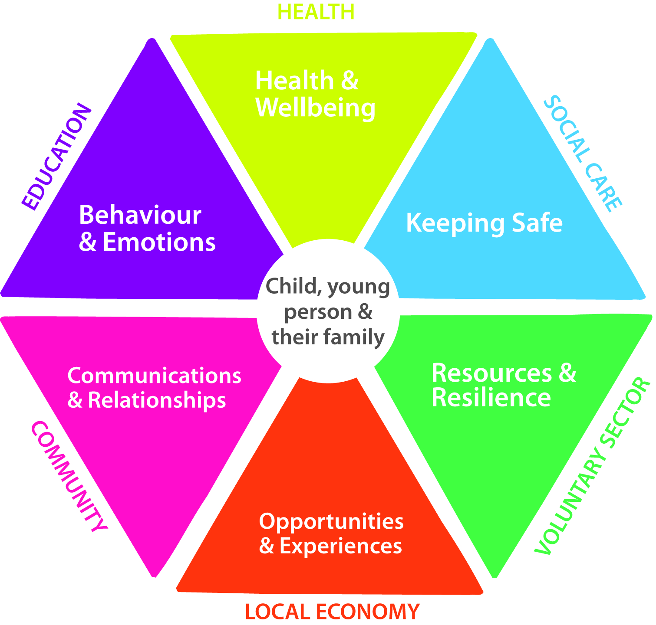

Thameside Primary School’s Provision Map contains examples of Wave 1, 2, 3 and 3+ provision across our school- it is not an exhaustive list.

It is important for all stakeholders to understand that the access of Wave 3 provision, on a short term basis, does not automatically imply that a child will be identified by the school as having a special educational need (SEN).

Behaviour and Emotions
Wave 1 | Wave 2 | Wave 3 | Wave 3+
- Access to support from an accredited SENCO  - Supported transition from nursery to school (FS)  - Parents’ evenings  - Independent learning promoted  - SENCO open door policy  - CAP workshops  - Visual timetables  - Differentiated planning  - Annotated planning, addressing needs  - The majority of our CTs and TAs are full time  - Variety of resources available  - Values focused approach  - Good learning behaviours taught and developed  - Children celebrated in assemblies  - Celebration in all areas of the curriculum  - Support for parents, including parent workshops  - Planned transition into following year group  - Range of learning styles catered for  - CPD for teachers  - Positive relationships  - Achievement recognised and valued  - Creative teaching ideas  - All children welcomed into school each morning by SLT on gates  - Supportive and trained TAs  - All children included and well prepared for activities or trips  - One page profile (OPP)  - Staff are courteous, responsive and accessible.  - Whole school behaviour policy – graduated response which leads to consistent behaviour management  - Class charters  - Reward systems  - Bespoke PSHE curriculum (to include circle time) – enhancing self esteem  - Flexible teaching arrangements – eg seating  - Managed playtimes  - Selected staff are team teach trained  - Lunchtime behaviour policy in place  - Values reward system for playtimes  - Engaged learners  - Insideout toolkit activities/lessons  - New pupil induction toolkit/checklist | - Intervention groups  - Nurture groups  - EAL support and intervention group run as required by TA with SALT input  - Behaviour support  - Sensory circuits  - Lunchtime circuits  - Support from floating TA  - Sense-ational breaks  - Lunchtime passports and key workers  - Vulnerable pupils’ transition group  - Social skills group eg turn taking  - Playtime monitoring  - Boxall profile or SDQs to identify needs  - Timers to promote independent learning  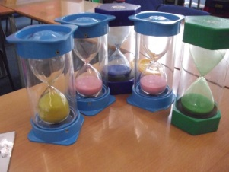 | - Behaviour plans  - Safe place in classroom  - Personalised pushing spots  - Structured time out if required  - Personal visual, audio or object related timetables  - EP support  - Drawing and talking therapy  - Play therapy  - Learning plans  - Support from ASD families advisor  - Recommendations from professionals swiftly put into place  - Any changes to support are successfully embedded after  consultation with stakeholders  - Welcoming and co-operative in working jointly to support families caring for children with special needs.  - Individual counselling (EP, PMHW or other)  - 1:1 close surveillance at playtimes  - Behaviour support team – individual intervention  - Additional planning and arrangements for transition  - Access to external agencies e.g. PMHW, EWDW, PASS worker | - 2:1 support  - 1:1 support  - Risk assessments for individual children  - Individual transition plans  - EHCPs

Health & Wellbeing
Wave 1 | Wave 2 | Wave 3 | Wave 3+
- Bespoke PSHE curriculum (to include circle time) – enhancing self esteem  - Access to school nurse  - Accident procedures  - First aid administered as required  - Selected staff are team teach trained  - Playtimes with a range of equipment  - Play leaders  - Opportunities to eat outside  - Residential trip (Y6)  - Onsite camping (Y4)  - Access to Christchurch Meadows for lessons  - Outdoor classroom  - Medicine administered as required with parental permission  - Supported transition from nursery to school (FS)  - Indoor and outdoor learning opportunities e.g.  - Decision making and problem solving activities  - Independent learning promoted  - Good parent liaison  - SENCO open door policy  - CAP workshops  - Differentiated planning  - Annotated planning, addressing needs  - Full time CTs and TAs  - Variety of resources available  - Values focused approach  - Good learning behaviours  - Educational trips and visits  - Children celebrated in assemblies  - Support for parents, including parent workshops  - Planned transition into following year group  - Enrichment  - Range of learning styles catered for  - CPD for teachers  - Positive relationships  - Achievement recognised and valued  - All children welcomed into school each morning by SLT on gates  - Supportive and trained TAs  - All children included and well prepared for activities or visits  - One page profile (OPP)  - Staff are courteous, responsive and accessible.  - Flexible teaching arrangements eg seating  - Lesson warm ups including music  - Staff aware of implications of sensory and physical impairment eg not covering mouth when talking to child with hearing impairment  - Resources eg reading and writing slopes, pencil grips  - Access to water bottles  - Access to support from an accredited SENCO  - Insideout toolkit activities/lessons  - New pupil induction toolkit/checklist  - Access to a first aid kit in each class | - Nurture groups  - Beginners support  - EAL support and intervention group run as required by TA with SALT input  - ELSA  - Sensory circuits  - Lunchtime circuits  - Support from floating TA  - Handwriting intervention, including activities to develop fine motor skills  - Sense-ational breaks  - Lunchtime passports and key workers  - Liaison with outside agencies  - Personalised physical warm up before group activities  - Auditory memory games – eg Kim’s Game  - Insideout days at Checkendon | - Personal visual, audio or object related timetables  - EP support  - Parental support via SEN forum  - Learning plans  - Support from ASD families advisor  - Recommendations from professionals swiftly put into place  - Any changes to support are successfully embedded after  consultation with stakeholders  - Support for families caring for children with SEN  - 1:1 close monitoring at playtimes  - Provision of specialist equipment –eg ICT screen magnifier, microphone for hearing aids, fitted chair, toilet facilities, own ear defenders  - TA individual support as required in PE  - Individual handwriting training | - 2:1 support  - 1:1 support  - Risk assessments for individual children  - Individual transition plans  - EHCPs

Keeping safe
Wave 1 | Wave 2 | Wave 3 | Wave 3+
- Risk assessments for trips or visits  - Labelled fire exits  - DBS checks for all staff  - PCSO regularly visits school  - School nurse  - Selected staff are team teach trained  - Coded or fobbed doors and gates  - Clutter free working environments  - Cold to touch hobs in the kitchen  - Safe environment  - Access to support from an accredited SENCO  - Indoor and outdoor learning opportunities  - Decision making and problem solving activities  - CAP workshops  - Differentiated and annotated planning, addressing needs  - Variety of resources available  - Safe learning environment  - Risk taking with confidence  - CPD for teachers  - Consistent behaviour management  - Positive relationships  - All children welcomed into school each morning by SLT on gates  - Good communication between parents, staff and external agencies  - All children well prepared for activities  - One page profile (OPP)  - Access to a first aid kit in each class  - First aid training for staff  - Up-to-date medical/allergy alert posters for pupils and procedures  - Thameside wrist bands are worn by all children on trips  - School equipment is risk assessed and safety checked annually  - PAT testing for equipment  - Positions of responsibility for children e.g. prefect monitors | - Nurture groups  - Behaviour support  - ELSA  - Lunchtime circuits  - Lunchtime passports and key workers | - Behaviour plans  - EP support  - Learning plans  - Support from ASD families advisor  - Recommendations from professionals swiftly put into place  - Any changes to support are successfully embedded after  consultation with stakeholders  - Support for families caring for children with SEN  - 1:1 close monitoring at playtimes  - Provision of specialist equipment –eg ICT screen magnifier, microphone for hearing aids, fitted chair, toilet facilities  - TA individual support as required in PE | - 2:1 support  - 1:1 support  - Risk assessments for individual children  - EHCPs

Examples of Resources (including external partners)
Wave 1 | Wave 2 | Wave 3 | Wave 3+
- Access to support from an accredited SENCO  - Resources eg reading and writing slopes, pencil grips  - Reading target cards  - Independent learning promoted  - Visual timetables (see photo)  - Parent helpers  - Full time CTs and TAs  - Variety of resources available  - Use of ICT e.g. iPads  - Interactive Whiteboards in every class (see photo)  - Library  - Outside classroom  - FS writing toolkits for children (see photo)  - Maths toolkits for parents  - Working walls (see photo)  - Mathletics  - One page profile (OPP)  - Class page on website  - Numicon and other practical resources in maths (see photo)  - Good quality texts in guided reading  - Use of stage for assemblies/performances  - Modelling  - Visual aids  - Access to headphones (see photo)  - Good quality resources  - Use of phonic aids – eg sound sheets, tactile letters, etc  - Use of writing frames  - Insideout toolkit activities/lessons  - New pupil induction toolkit/checklist  - Outdoor maths resources (see photo) | - Beginners support  - EAL support and intervention group run as required by TA with SALT input  - Behaviour support  - Coloured cellophane or overlays for reading  - Numicon intervention  - Sense-ational break boxes  - Talking tins  - Lunchtime passports and key workers  - Differentiated resources  - Reading support volunteers  - Use of writing frames  - Timers  - Calm boxes for children  - Nessy online reading/spelling programme  - Insideout days at Checkendon | - Behaviour plans  - Support from SALT TA  - Personal visual, audio or object related timetables  - EP support  - Learning plans  - Support from ASD families advisor  - 1:1 reading screening  - 1:1 precision teaching of reading teacher and/ or TLA –  - Auditory memory programme  - LSS support  - WRAT reading assessment to identify gaps | - 2:1 support  - 1:1 support  - Risk assessments for individual children  - Individual transition plans  - EHCPs  - Additional 1:1 precision teaching of reading - HT  - daily  - 1:1 intensive support for literacy or numeracy  - Additional planning and arrangements for transition  - 1:1 tuition  - Dual placements considered where appropriate
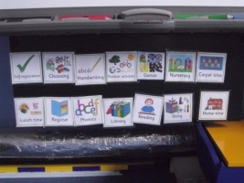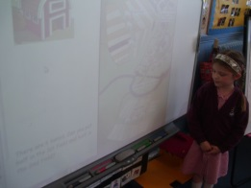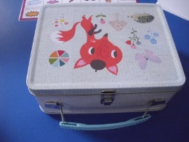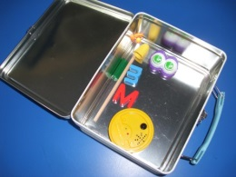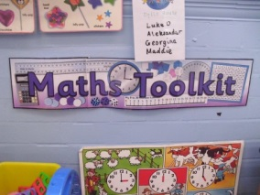
Visual timetable Interactive Whiteboard Writing toolkits for children Maths working walls
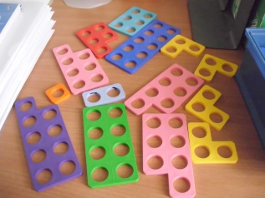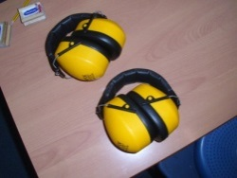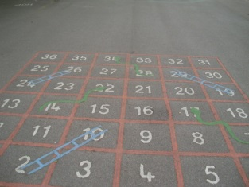
Numicon Headphones Maths in the playground

Opportunities and Experiences
Wave 1 | Wave 2 | Wave 3 | Wave 3+
- Access to support from an accredited SENCO  - Baseline assessments (FS)  - Ongoing assessments and observations  - Supported transition from nursery to school (FS)  - PSHE curriculum (to include circle time) – enhancing self esteem  - Indoor and outdoor learning opportunities  - Teacher led activities  - Parents’ evenings  - Decision making and problem solving activities  - Reading target cards  - Independent learning promoted  - Good parent liaison  - SENCO open door policy  - Small group work  - CAP workshops  - Visual timetables  - Parent helpers  - Differentiated planning  - Annotated planning, addressing needs  - Majority of CTs and TAs are fulltime  - Variety of resources available  - Real/context learning experiences  - Engaged learners  - Safe learning environment  - Risk taking with confidence  - Values focused approach  - Good learning behaviours  - Perform on a stage  - Tracking of progress  - Pupil progress meetings  - Venn target setting and groupings  - Close the gap marking, including pupil response  - Writing symbols (FS & KS1) (see photo)  - Educational trips and visits  - Assemblies to watch and perform in  - Every child celebrated in assemblies  - Celebration in all areas of the curriculum  - Parents as partners  - Teachers provide detailed targets to all parents  - Support for parents, including parent workshops  - Library time  - Daily phonics (FS & KS1)  - Use of ICT e.g. iPads  - Planned transition into following year group  - Enrichment  - Range of learning styles catered for  - Targets/ next steps for children  - Trips providing experiences in a range of subjects  - Subject experts  - CPD for teachers  - Safe learning environment  - Insideout toolkit activities/lessons  - New pupil induction toolkit/checklist  - Consistent behaviour management  - Working walls  - Positive relationships  - Achievement recognised and valued  - Creative teaching ideas (see photo)  - Personalised targets  - All children welcomed into school each morning by Head or member of Senior Leadership Team  - Supportive TAs  - Mathletics and maths club  - All children included and well prepared  - One page profile (OPP)  - Staff are courteous, responsive and accessible.  - Food technology in modern kitchen  - Opportunities to work with children from other settings  - Represent the school  - Talking partners  - Whole school trips  - Flexible teaching arrangements  - Displays support learning (see photo)  - Therapeutic thinking school | - Intervention groups  - Nurture groups  - Beginners support  - EAL support and intervention group run as required by TA with SALT input  - Behaviour support  - ELSA  - Sensory circuits  - Lunchtime circuits  - Support from floating TA  - Breaking barriers maths intervention  - Phonics support groups  - Target teach groups as identified in pupil progress meetings  - Handwriting intervention, including activities to develop fine motor skills  - TA interventions  - Sense-ational breaks  - Writing bypass strategies e.g. talking tins  - 1:1 reading (KS2)  - Lunchtime passports and key workers  - Differentiated homework activities  - In class TLA literacy and numeracy support  - Withdrawal groups  - Differentiated phonic/ spelling groups  - Differentiated resources  - Intensive reading support – small group reading  - Vulnerable pupil transition group  - LSS support  - Surgeries and focussed small group work  - Reading support volunteers  - Differentiated curriculum planning  - Differentiated learning outcomes and activities  - Nessy online reading/spelling programme  - Insideout days at Checkendon | - Personal visual, audio or object related timetables  - EP support  - Learning plans  - Support from ASD families advisor  - Recommendations from professionals swiftly put into place  - Any changes to support are successfully embedded after  consultation with stakeholders  - Support for families caring for children with SEN  - Individual arrangements for SATs (Y6) | - 2:1 support  - 1:1 support  - Risk assessments for individual children  - Individual transition plans  - EHCPs
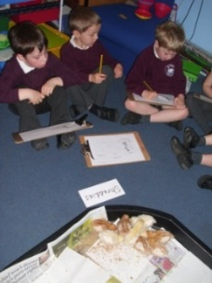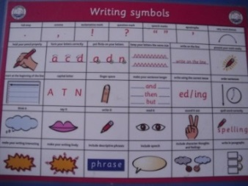
Real life experiences Writing symbols
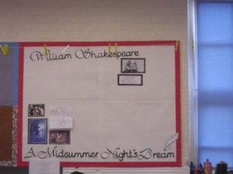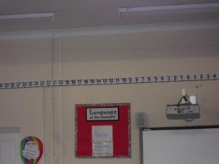
Creative teaching ideas Displays to support learning

Communications & Relationships
Wave 1 | Wave 2 | Wave 3 | Wave 3+
- Access to support from an accredited SENCO  - Supported transition from nursery to school (FS)  - PSHE curriculum (to include circle time) – enhancing self esteem  - Parents’ evenings  - Decision making and problem solving activities  - SENCO open door policy  - CAP workshops  - Visual timetables  - Parent helpers  - Majority of CTs and TAs are fulltime  - Values focused approach  - Close the gap marking, including pupil response  - Children celebrated in assemblies  - Celebration in all areas of the curriculum  - Parents as partners  - Teachers provide detailed targets to all parents  - Support for parents, including parent workshops  - Email, texts and letters support good home/school correspondence  - Planned transition into following year group  - Targets/ next steps for children  - Consistent behaviour management  - Positive relationships  - Achievement recognised and valued  - All children welcomed into school by Head  - Supportive TAs  - All children included and well prepared  - One page profile (OPP)  - Staff are courteous, responsive and accessible.  - Clear learning objectives  - Structured school and classroom routines  - Use of symbols e.g. when writing success criteria  - A number of our teaching staff speak several languages including Spanish, Bengali, German, Hungarian, Polish and Urdu. This can support a smoother transition for EAL children.  - Insideout toolkit activities/lessons  - New pupil induction toolkit/checklist | - Intervention groups  - Nurture groups  - Beginners support  - EAL support and intervention group run as required by TA with SALT input  - Behaviour support  - ELSA  - Sensory circuits  - Lunchtime circuits  - Support from floating TA  - Phonics support groups  - Talking tins  - Lunchtime passports and key workers  - Differentiated delivery eg, simplified language, slower lesson pace  - Increased visual aids  - Increased modelling  - Use of phonic aids – eg sound sheets, tactile letters, etc  - Insideout days at Checkendon | - Behaviour plans  - Personal visual, audio or object related timetables  - EP support  - Learning plans  - Recommendations from professionals swiftly put into place  - Any changes to support are successfully embedded after  consultation with stakeholders  - Welcoming and co-operative in working jointly to support families caring for children with special needs.  - TL 1:1 delivery of SALT programmes  - Makaton signing (where applicable)  - Additional arrangements for transition  - In class TA support – simplified language  - In class LA support to aid delivery of learning plan targets  - Playground monitoring  - Vulnerable pupils transition group | - 2:1 support  - 1:1 support  - Risk assessments for individual children  - Individual transition plans  - EHCPs

