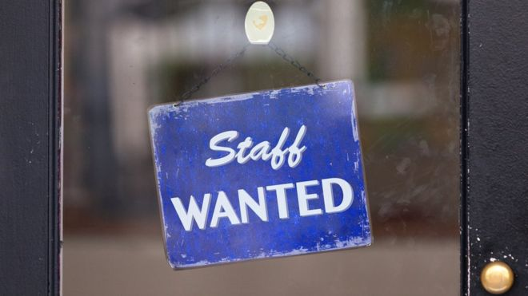
Vacancies: Most 18+ due to health situation:
BBC link from 26 March - https://www.bbc.co.uk/news/business-52040539
Tesco said last week it is bringing in up to 20,000 new colleagues to work in its stores for at least the next twelve weeks. You can apply here.
Asda said it wanted to recruit more than 5,000 temporary staff from the pool of workers whose jobs have been impacted by the virus. Here is the application site.
Aldi announced it was looking to fill 5,000 new temporary posts and take on 4,000 permanent new workers for jobs in all its stores and distribution centres. Details can be found here.
Morrisons said it would be recruiting about 2,500 pickers and drivers, plus 1,000 staff in its distribution centres. It's accepting applications here.
Lidl said it would create about 2,500 temporary jobs across its 800 stores in the UK. The jobs site is here.

1,500 jobs at Lloyds Pharmacy
The chemist chain needs 1,500 temporary and permanent roles filling over the coming days. Vacancies include dispensers, pharmacists, delivery drivers and warehouse staff across its 1,400 branches.
For information on the roles and to apply, click here.

500 jobs at Virgin Media
The phone and internet company are creating 500 new UK contact centre jobs to help keep customers connected during the coronavirus pandemic.
People can apply here.

Hundreds of jobs at Community Integrated Care
The social care charity has hundreds of new vacancies across the country.
It says: "We are currently recruiting for hundreds of support worker roles across England and Scotland to help support vulnerable people with their daily routines."
Candidates can register their interest here.

Sainsburys:
https://sainsburys.jobs/search-apply/?origin=51.4260269,-0.8509764999999999&maxdist=9&location=rg14hj
https://www.staffline.co.uk/jobs/morrisons
Waitrose - https://www.jlpjobs.com/covid-19-update/

Other vacancies & volunteering:
Postmen/women vacancies:
www.catchwork.co.uk

Reading voluntary Action group: https://rvaforms.wufoo.com/forms/zecqa871u9blv3/
NHS volunteers - (18+) roles include calling people your home to check they are OK and two other roles using transport (can apply if you have a bike)
https://www.goodsamapp.org/NHSvolunteerresponders

